**Assignment 4 Report**

*Part 1: Vector implementation*

* Case 1: One occurrence of number in vector
  + As shown by the screen shot below, the number “2” only occurs once, therefore the number “1” is only added once. It is added after “2”, which is its correct position.

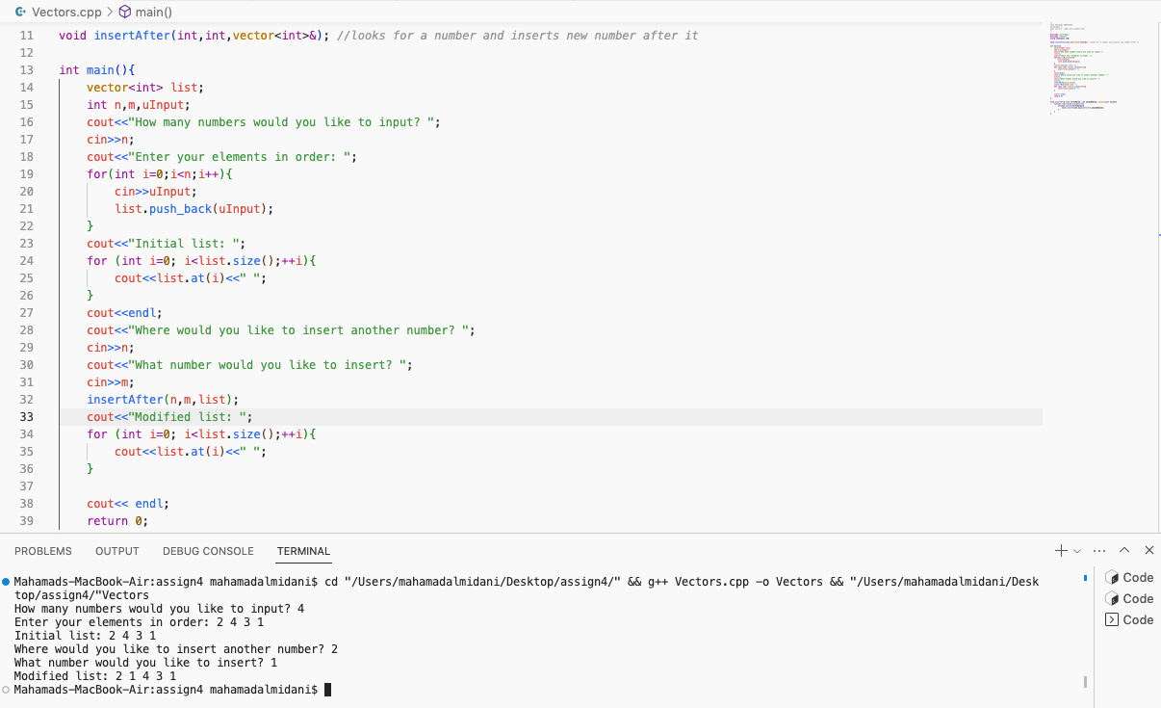

* Case 2: Multiple occurrences of number
  + As seen in the screenshot below, the number “1” appears 3 times, so “6” is inserted 3 times. All 6’s are inserted after the 1’s, and the order remains correct.

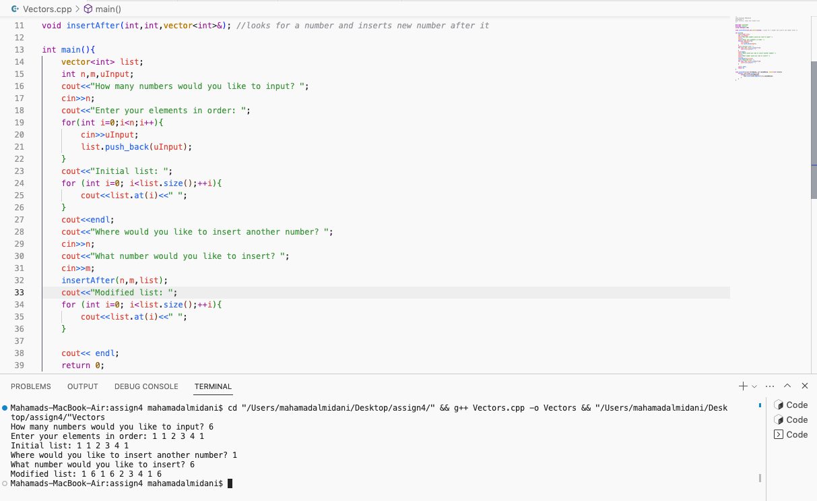

* Note: Couldn’t remember the syntax of insert function, so a source was used (referenced below).

*Part 2: Linked list implementation*

* Note: I implemented a very simple driver main function in order to test the code. Although very simple, it effectively shows how each function works (Will be attached in the repo).
* I implemented a class called LinkedList, as well as a struct Node for this assignment.
  + Function definitions of LinkedList in separate .cpp file

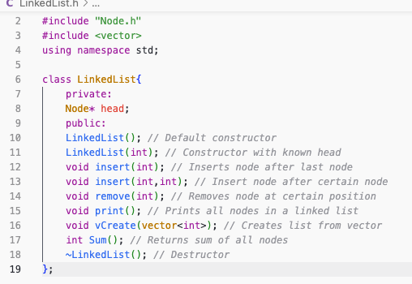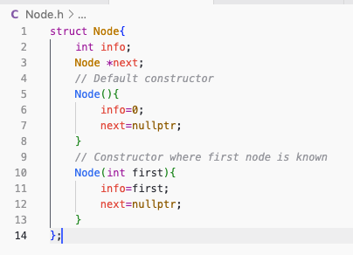

* Terminal of driver main:

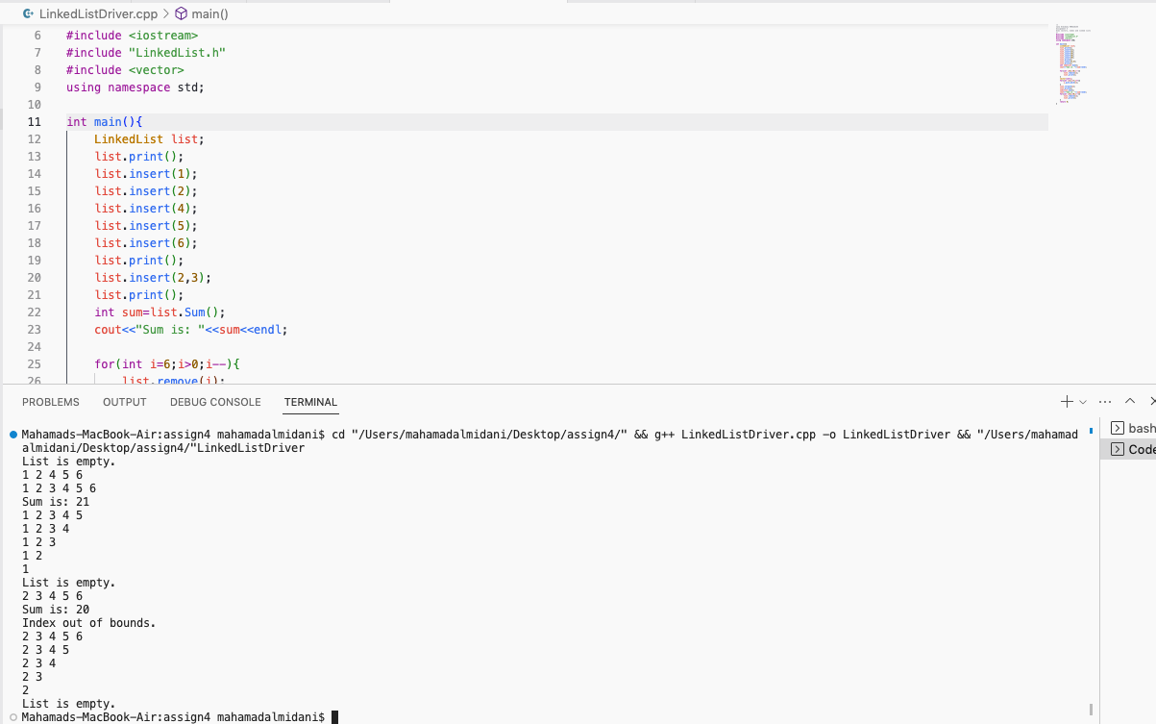

* Explanation:
  + List starts off empty so print function outputs “List is empty” → ensures error message correctness
  + All insert functions work as shown by the print function
  + The overloaded insert function with 2 parameters’s function is to insert 3 after 2, which it does
  + The sum of all numbers in the linked list is 21, which is correct
  + Then we start removing the nodes one by one and printing each time, ensuring that the remove function works properly
  + Once emptied, displays message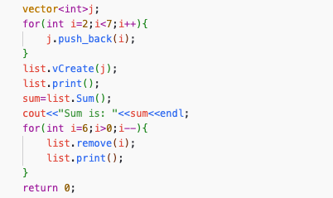
  + Another list is created, this time using vectors (code in screen shot)
  + Another print function ensures that the vCreate (vector create) function works accurately
  + A sum is derived from it, then its nodes are emptied one by one, just like in previous section
  + Once its empty message is displayed
* As shown, everything works properly
* Notes:
  + I had many technical issues with debugging the code. They were minor things like putting “temp->next->next” instead of “temp->next”, or putting head=temp->next instead of the oppoite. However, I did understand the problems. I compared my code to other codes (linked below) in order to help spot errors
  + I was unfamiliar with the syntax of functions like push_back(n) and at(n), which is why I used a website to check their syntax (linked below)

Works Cited

GeeksforGeeks. (2023, April 10). *Vector insert() function in C++ STL*. GeeksforGeeks. Retrieved April 12, 2023, from https://www.geeksforgeeks.org/vector-insert-function-in-c-stl/

GeeksforGeeks. (2023, February 17). *Program to implement singly linked list in C++ using class*. GeeksforGeeks. Retrieved April 12, 2023, from https://www.geeksforgeeks.org/program-to-implement-singly-linked-list-in-c-using-class/

GeeksforGeeks. (2023, January 11). *Remove first node of the linked list*. GeeksforGeeks. Retrieved April 12, 2023, from https://www.geeksforgeeks.org/remove-first-node-of-the-linked-list/